All councillors are summoned to attend the Parish Council Meeting of the Cronton Parish Council on Monday 7th September 2026 at the Parish Council Office at 7pm
Cllr. G Thomas – Parish Council Chair

AGENDA
MEETING OF THE CRONTON PARISH COUNCIL

Date | Monday 7th September 2026
Venue | Cronton Parish Office
Expected Attendees | Cllr Gordon Thomas  Cllr Rosanne Hayes  Cllr Ged McGann  Cllr Rachel Fielding  Cllr Colin Thistlewood  Cllr Lynne Heywood  Cllr Debbie King  Cllr Karthikeyan Selvam  Clerk & RFO, Helen Howard  Cllr R Gaffney – Ward Councillor  Cllr T Byron – Ward Councillor  Cllr D Gilbertson – Ward Councillor
Apologies

For all sets of minutes and backing papers it is taken that all will have been pre-read and coverage will therefore be limited to: • accuracy • action points • challenge.

AGENDA ITEM 1 | WELCOME & APOLOGIES FOR ABSENCE.
1.Councillors are reminded that records of councillor’s attendance are required to be published to the Parish website.
2. Welcome new Councillors Debbie King and Karthikeyan Selvam.

AGENDA ITEM 2 | DECLARATIONS OF INTEREST.
1. Councillors are reminded of the need to update their register of interest.
2. To declare any personal interest in items on the agenda and their nature.
3. To declare any prejudicial interest in items on the agenda and their nature.
(Councillors and their prejudicial interests must leave the room for the relevant items)

AGENDA ITEM 3 | MINUTES OF THE LAST MEETING (13th July 2026)
 | To receive and approve the minutes of the last meeting. Any points of accuracy should be addressed in this item.

AGENDA ITEM 4 | REVIEW OF OUTSTANDING ACTIONS
 | To receive an update on actions arising from previous meetings and to note completed actions, agree revised timescales where necessary, and close completed items.

AGENDA ITEM 5 | PUBLIC PARTICIPATION
The public is invited to ask questions and make representations in respect of the business on the agenda. The time allocated is at the discretion of the chair –
Notes from this section will appear in the minutes of the meeting.

AGENDA ITEM 6 | WARD COUNCILLOR REPORTS
To receive Ward Councillor Reports.
Cllr T Byron
Cllr R Gaffney
Cllr D Gilbertson

AGENDA ITEM 7 | UPDATE ON PLANNING RELATED CONCERNS
- Verbal report from Cllr Thomas outlining progress of the cumulative traffic report in relation to all proposed new developments locally – ie Chapel Lane, Cronton Road, Bloor Homes (old JLR), site adjacent Cronton College.
- Representation at Chapel Lane Appeal public meeting on 22nd September

AGENDA ITEM 8 | WORKING GROUPS REPORTS
Verbal reports up to 5 minutes for information, more detailed reports to be submitted in writing.
Please ensure all actions as recorded in July’s minutes are updated.

Budget - Working Group - GT

Planning -Working Group - LH

Community Events - Working Group – RH
- Grant applications to be discussed under finance item

Compliance / Policies /Website - Working Group – CT
Social Media & Communications policy has been circulated for consideration:
  - Council Resolution for Adoption of Communications policy
MOTION TO RESOLVE THAT:
- The Parish Council adopts the Social Media and Communications Policy with effect from [date].
- The Clerk is authorised to administer the Council’s official communication channels in accordance with the policy.
- The Clerk is authorised to make minor administrative amendments where necessary to maintain the accuracy of contact details, platform information or references to legislation and guidance, provided that such amendments do not materially alter the policy.
- Any material amendment to the policy shall be brought before the Parish Council for approval.
- The policy shall be reviewed no later than 12 months from date of adoption.

Environmental - Working Group - RH

Neighbourhood Development Plan - Working Group - GMG

AGENDA ITEM 9 | OFFICE REFURB

New noticeboards – agreement on colour.
- New flooring – 3 quotes received for main office and clerk’s office inclusive of VAT:
- Laminate flooring, trims and matwell overlaid on existing carpet - £1495.00
- Laminate flooring, underlay, trims and matwell with existing carpet removed and disposed of - £2535.00
- Laminate flooring, underlay and trims with existing carpet removed and disposed of - £2366.40
To agree and approve preferred option.

AGENDA ITEM 10 | PASTURE PERIMETER FENCING
 | Order to be placed – see agenda item 12 finance

AGENDA ITEM 11 | NEWSLETTER
Feedback on Summer edition.
Topic points for Autumn edition.

AGENDA ITEM 12 | FINANCE

Receipts and Payments/Bank Reconciliation
Bank reconciliation will be provided at meeting.
Update on progress with changes to Natwest bank access and signatories.

Invoices for Approval (non direct debits)
Aragorn Hosting Ltd (CPC website) £216.00 due 01/10/26 annual payment

Payments / Refunds due
NALC fees overdue (payment oversight) £276.18
HMRC refund due c£900 (historic P30 overpayments)

Precept/Budget
Fencing, elections and office refurb. to be allocated against correct cost centres.
Fencing quotation: £975+VAT=£1170
Clerks’ Pay Settlement 2026-27 retrospectively from 1st April 2026
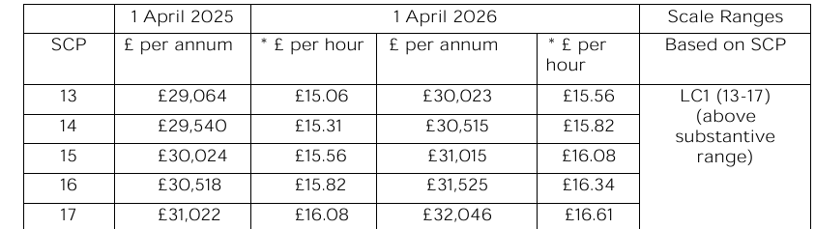

Bank Signatories-
Verbal update from Clerk on progress to date

Grants
Grants to be opened up to use what is available.
Community Centre will be submitting a grant application.

Remembrance Day
Procurement of approx. 20 additional poppies to be agreed.
Cllr Thomas to source quality wreath.
Cllr Hayes has sourced large replacement flag.
Remembrance Day budget £250.

Amazon Business Account
Account has been set up.

AGENDA ITEM 13 | DATE OF NEXT MEETING
 | Monday 12th October

