All councillors are summoned to attend the Parish Council Meeting of the Cronton Parish Council on Monday 13^{h} July 2026 at the Parish Council Office at 7pm
Cllr. G Thomas – Parish Council Chair

AGENDA
MEETING OF THE CRONTON PARISH COUNCIL

Date | Monday 13th July 2026
Venue | Cronton Parish Office
Expected Attendees | Cllr Gordon Thomas  Cllr Rosanne Hayes  Cllr Ged McGann  Cllr Rachel Fielding  Cllr Colin Thistlewood  Cllr Lynne Heywood  Clerk & RFO, Helen Howard  Cllr R Gaffney – Ward Councillor  Cllr T Byron – Ward Councillor  Cllr D Gilbertson – Ward Councillor
Apologies

For all sets of minutes and backing papers it is taken that all will have been pre-read and coverage will therefore be limited to: • accuracy • action points • challenge.

AGENDA ITEM 1 | WELCOME & APOLOGIES FOR ABSENCE.
 | Councillors are reminded that records of councillor’s attendance are required to be published to the Parish website.

AGENDA ITEM 2 | DECLARATIONS OF INTEREST.
1. Councillors are reminded of the need to update their register of interest.
2. To declare any personal interest in items on the agenda and their nature.
3. To declare any prejudicial interest in items on the agenda and their nature.
(Councillors and their prejudicial interests must leave the room for the relevant items)

AGENDA ITEM 3 | MINUTES OF THE LAST MEETING (8th June 2026)
 | To receive and approve the minutes of the last meeting. Any points of accuracy should be addressed in this item.

AGENDA ITEM 4 | REVIEW OF OUTSTANDING ACTIONS
 | To receive an update on actions arising from previous meetings and to note completed actions, agree revised timescales where necessary, and close completed items.

AGENDA ITEM 5 | PUBLIC PARTICIPATION
The public is invited to ask questions and make representations in respect of the business on the agenda. The time allocated is at the discretion of the chair –
Notes from this section will appear in the minutes of the meeting.

AGENDA ITEM 6 | CO-OPT OF NEW COUNCILLORS
 | Motion for co-option of two applicants to the Council, proposed by Cllr Gordon Thomas.

AGENDA ITEM 7 | WARD COUNCILLOR REPORTS
To receive Ward Councillor Reports.
Cllr T Byron
Cllr R Gaffney
Cllr D Gilbertson

AGENDA ITEM 8 | UPDATE ON PLANNING RELATED CONCERNS
To follow up on non-response from Alan Kilroe
To discuss Chapel Lane appeal by TW
Updates on Cronton Road development
Updates on Bloor Homes development (Cronton adjacent)
Planning application below (Cronton adjacent)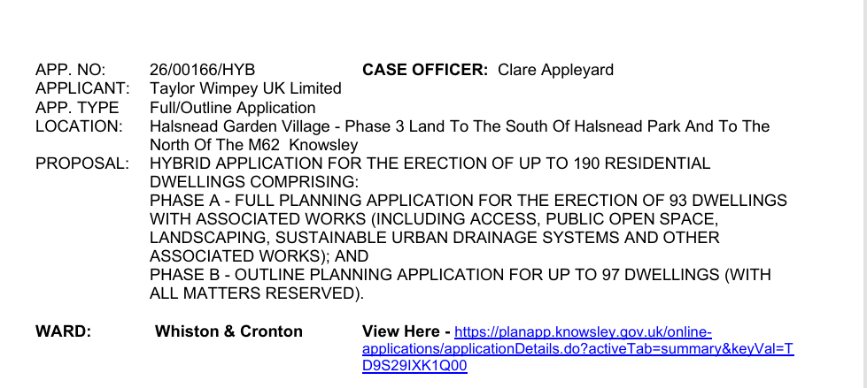

AGENDA ITEM 9 | WORKING GROUPS REPORTS
To receive for information only the undermentioned verbal reports:

Please ensure all actions as recorded in June’s minutes are updated.

Budget - Working Group - GT

Planning -Working Group - LH

Community Events - Working Group – RH
- Confirmation of date for Living Well bus 14th August
- Agreement to publicise availability for community groups to apply for grants

Compliance / Policies /Website - Working Group - CT

Environmental - Working Group - RH

Neighbourhood Development Plan - Working Group - GMC

AGENDA ITEM 10 | OFFICE REFURB

Verbal report on progress from Cllr Fielding and Cllr Thomas.
New front door lock fitted, new keys to be issued.

AGENDA ITEM 11 | PASTURE PERIMETER FENCING
 | Motion for replacement of perimeter fencing at Cronton Pasture, proposed by Cllr Hayes, seconded by Cllr Thomas.

AGENDA ITEM 12 | NEWSLETTER
 | Review and approve draft newsletter.

AGENDA ITEM 13 | FINANCE

Receipts and Payments/Bank Reconciliation
Bank reconciliation if available will be provided at meeting.
Update on progress with changes to Natwest bank access and signatories.

Invoices for Approval (non direct debits)
Payment to R Fielding for door furniture
Payment to Jon Smith Locksmiths for front door lock and keys

Precept/Budget
To acknowledge creation of separate reserve locations for fencing, elections and office refurb.

Bank Signatories-
Signatories to be removed from banking system
D Rostance
S Cooper
S Boyd

Current Signatories also have access to the online banking system –
R Hayes
G Thomas (does not have app access yet only an approved signatory)

Signatories that need to be added onto the online banking system
Woods and Cooper payroll provider – This is standard procedure for any payroll provider and would only have access to the current account which does not effectively hold any funds.

Amazon Business Account
Motion to open a business account with Amazon to streamline the ordering of office consumables, proposed by Cllr Thomas.

AGENDA ITEM 14 | DATE OF NEXT MEETING
 | Monday 7th September

AGENDA ITEM 15 | EXEMPT ITEM
 | Confidential external report

